**Survey Results as of 5/18 11:59 p.m.**

**1. VOLUME ON STREETS**

**55% - Higher:** 41% significantly more; 14% slightly more

18% - Same

18% - Lower

others have not noticed animals on streets

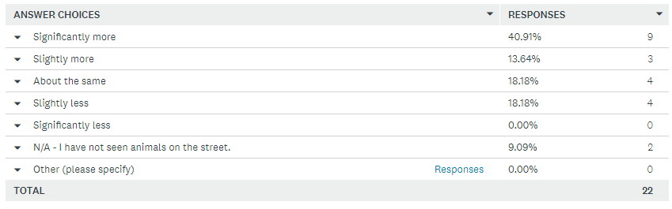

**2. CONDITION OF STREET ANIMALS**

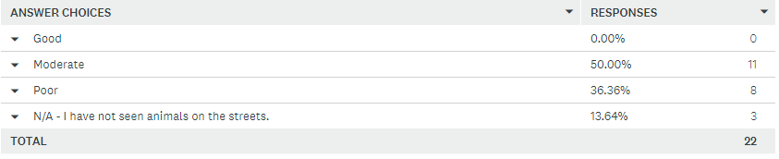

**3. DEMAND FOR SERVICES COMPARED TO THIS TIME LAST YEAR** (apples to apples)

**68% - Higher:** 27% significantly higher; 41% slightly higher

18% - Same

14% - Lower

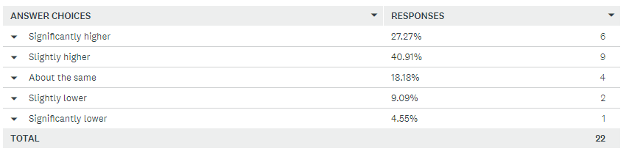

**4. IMPACT ON ORG SINCE COVID HIT**

Since COVID began, there has been an uptick in:

- animals coming into our partners' programs

- adoptions

- foster placements as more fosters have come forward to help. We hope this trend continues

- need for services

Conversely, there has been a decline in financial contributions and in-kind donations

(about half say more animals in their shelter, and half say less)

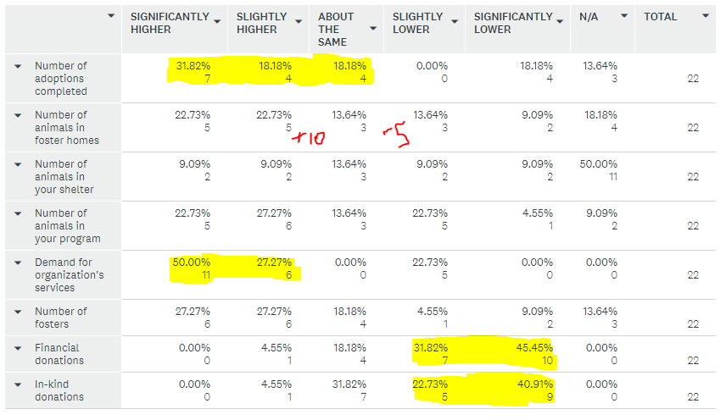

**5. COVID IMPACT CONCERNS**

What concerns do you have about how COVID-19 could impact animal welfare in Greater Houston?

Concerns summary:

* Influx of animals to shelters as people cannot afford their animals and/or as people return to work and bring in fosters or return adopted pets
* Increased number of animals on the street:
  + due reduced intake at shelters leading to dumping and leaving strays that would have been brought in
  + new litters from unaltered street animals
* Returning to pre-COVID levels of donations, volunteers and shelter visitors
* Health of employees/volunteers

Direct responses:

* Potential adopters do want to visit Volunteers do not want to volunteer
* Worried about people returning dogs when life goes back to normal.
* More animals will be left on the streets to fend for themselves, and reproducing will increase.
* We are concerned the number of owner surrenders may increase due to job losses or lack of time as owners return to work.
* more abandoned dogs from owners who are out of work or unable to provide care/shelter
* Animal being abandoned more frequently or turned into the shelters more frequently due to economic down turn.
* The Rescue Center is getting significantly more "drop offs" left in boxes, carriers, etc at our door. Because we are not open to the public right now, our phones are going nuts.
* Because our State Govt including Abbot and Patrick are hell bent on opening the state regardless of precaution I am worried that the large municipal elections shelters will remain mostly shut down as they are now. We have worked very hard to start to get on top of Houston’s homeless pet overpopulation problem and we might give all that progress back up if our local state and federal govt fails to bring COVID under control.
* That the pet overpopulation will increase.
* Although the adoption rate has increased I do have a concern about when people return to work their commitment is still there for wanting an animal.
* For our organization, we only do seniors, so we typically don't have people making ad hoc decisions about an older dog. We do have a concern about all the people who have adopted puppies while sheltering in place and what will happen once they go back to work.
* donations will continue to be slim to none the needs of the animals greater
* The two shelters in Montgomery County have refused to intake dogs, which has swamped rescue organizations and citizens, as well has directly resulted in hundreds of animals being dumped on the streets.
* People no longer financially being able to care for their pets.
* Many animals being dumped on streets, and many litters being born on the streets. Obviously, this leads to injury, abuse, disease, etc. With the cancellations of large scale spay / neuter efforts, I worry about future unwanted litters. As a transport based rescue, I personally worry About a second wave of COVID and related closures nationally. (We needed to cancel 5 transports of approx 50 dogs each, and that is just our small rescue
* Too many animals and not enough resources
* Concerned the number of animals coming out of foster will flood our local shelters.
* I am hoping we do not see a high number of returns once this is all over. Lots of animals have found homes and I hope they get to stay!!
* Concerns that limited intake at municipal shelters means more pets dumped on the streets if rescues don't have the foster base to take them in immediately.
* Lack of stray animals being fed.
* People are abandoning pets and even pets that are found individuals are not able to afford to care for that normally would help with expenses and care
* Abandoned cats due to misinformation about them contracting/spreading COVID-19

**6. ORGANIZATIONAL NEEDS**

Biggest needs - funding to meet the demands and fosters

Direct responses:

* Donations Our donations have declined by 50 percent, our labor expenses have increased two fold.
* Fosters and donations (whether it be monetary, food, pee pads, etc)
* Financially, a successful MMM event in April! Overall, we want to be back regularly volunteering at BARC!
* Fosters for dogs and funds to replace the cancelled fundraising events.
* more fosters and donations to care for an increase in heartworm positive dogs in our care
* Low cost s/n services. Additional transport partners. Larger dog marketing.
* More of everything!
* people to accept wearing masks in public. It appalls me at our S/N clinic when people come in not masked. This puts all of our staff at way higher risk than they should have to experience. We are going to adopt a faœmask required policy to enter our facility.
* Working resources that can be paid.
* Operational funds to continue to provide veterinarian services needed
* Ways to fundraise since we can't hold in person fundraisers yet and for likely some time
* I'm just slowing down intake so I can better care for what is my responsibility
* Financial donations to purchase heartworm treatment medications.
* Donations to help with increased costs.
* Come 5/28, we are back on track, and hopefully will not have any additional needs.
* money for vet services
* We need rescue groups to use our boarding facility.
* Overall we are doing well. We have had to tap into our emergency fund a bit for the first time ever. We just want to have events again.
* Funds for temporary boarding, or a donated building or land to create own facility.
* Donations
* New fosters
* Funds/donations, more hands to help manage the load of animals in need

7. POSITIVE RESULTS FROM COVID

SUMMARY:

* Awareness of need to help animals animals
  + foster/adopt
  + help animals that are sometimes harder to place
  + prevent cruelty
* Collaboration among the rescue community

Direct Responses:

* More dogs getting saved.
* It seems more rescues have fostered more, and BARC itself has made some building and policy changes!
* With people staying at home, we have had new fosters step up and in general it looks like more people are adopting from shelters. Unfortunately, we anticipate a rebound when those who adopted from shelters return to work. We expect a number of those will be returned or abandoned.
* more people willing to foster, more adoptions.
* We are able to insist that the community "finders" and "owners" step up to foster rather than expecting rescue and shelters to provide all the answers. Greater respect for contagious diseases.
* I have not seen very many changes, as I only can say for my Rescue.
* Large number of new fosters and adopters. Our fear is this goes away as people start going back to work. Our large volunteer network is still hanging with us. We Ask for volunteers to do a specific job and they respond.
* Awareness of the issue is improving.
* Foster homes and adoptions have increased slightly since people are home.
* A larger number of people wanting to share their lives with seniors and supporting our mission.
* animal neglect/cruelty seems to be better identified and dealt with
* Rescue organizations in Montgomery county have really stepped up and worked together to make up for the lack of shelter services.
* So many more people home able to foster and adopt
* Many animals in shelters adopted or placed in foster homes!
* more people are home so more are adopting but we are starting to see this decline
* Having applicants fill out the adoption application prior to their visit has saved staff a lot of time. On a separate note, many of our harder to adopt dogs have been adopted.
* Our volunteers and fosters have really pulled together.
* Certainly most people are willing to hang on to a found pet short-term in order for them to join our program. When people are at home more, they are also willing to foster. Unfortunately as people return to work, they won't be fostering any longer.
* Lots of applications coming in
* more groups working together to get an animal help if
* Increase in people willing to volunteer and make a difference in more animalsâ€™ lives